## Assignment 2: Aggregates and Nested Subqueries

### Statement : Write the SQL queries using aggregates, grouping, ordering statements and nested subqueries for given statements on given schema.

### Intermediate SQL: Aggregates and grouping and ordering

### 1.

### 

**2.** 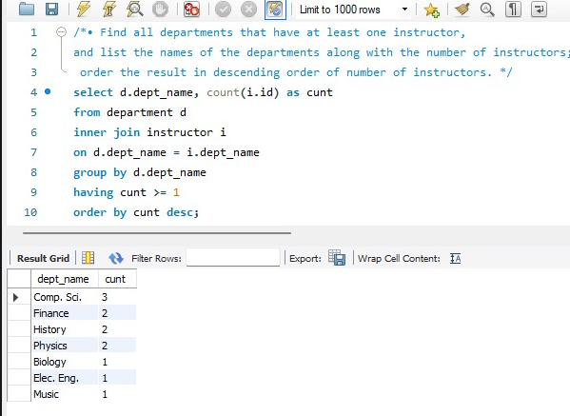

**3.**

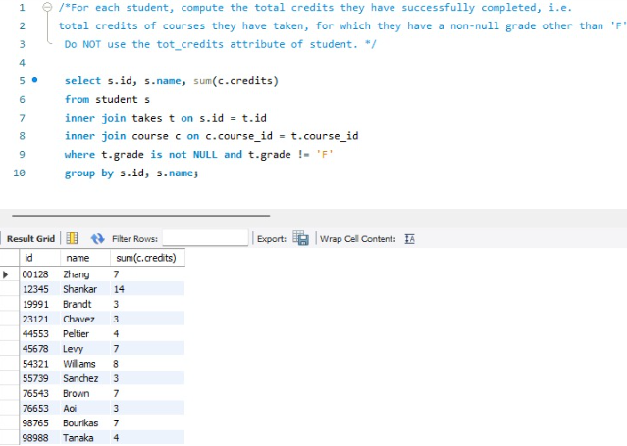

**4**.

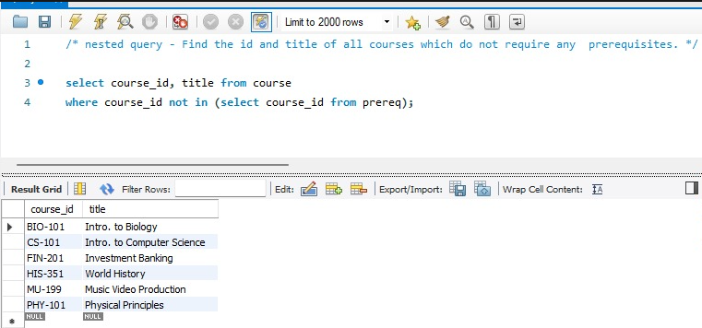

**Nested Subqueries** : Write the following queries for university schema.

* Find the id and title of all courses which do not require any prerequisites.

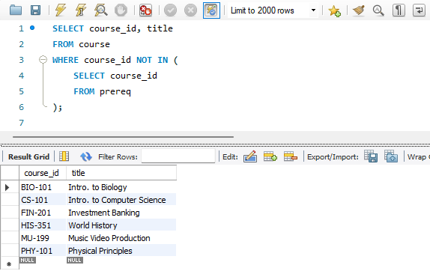

* Find the names of students who have not taken any biology dept. courses.

